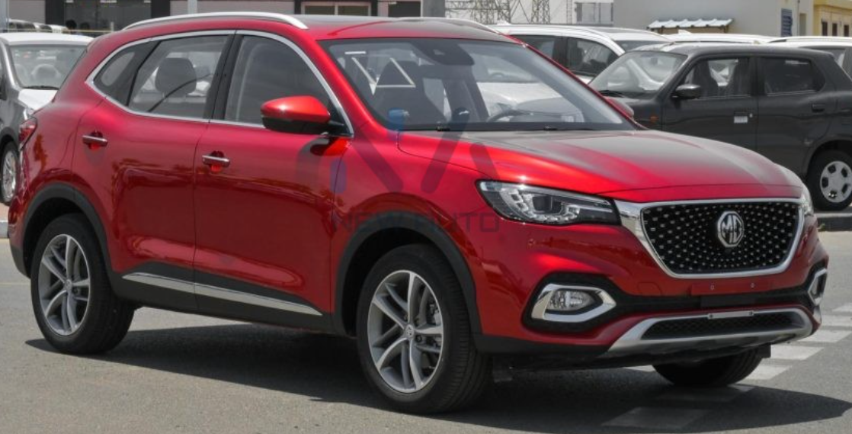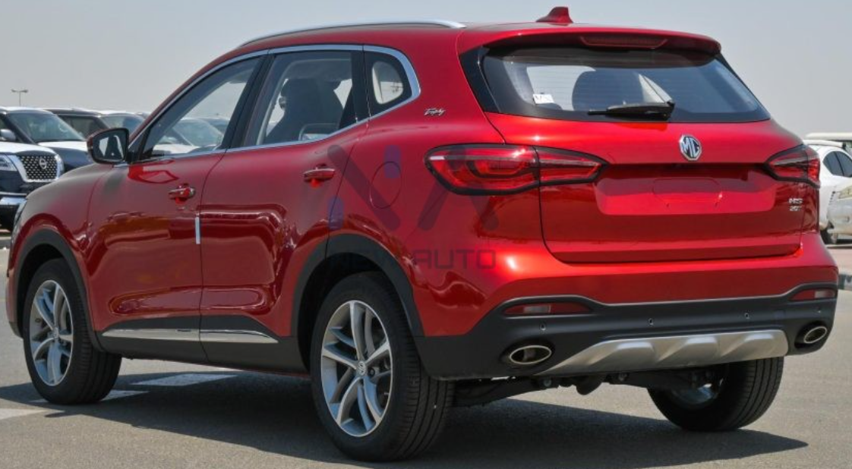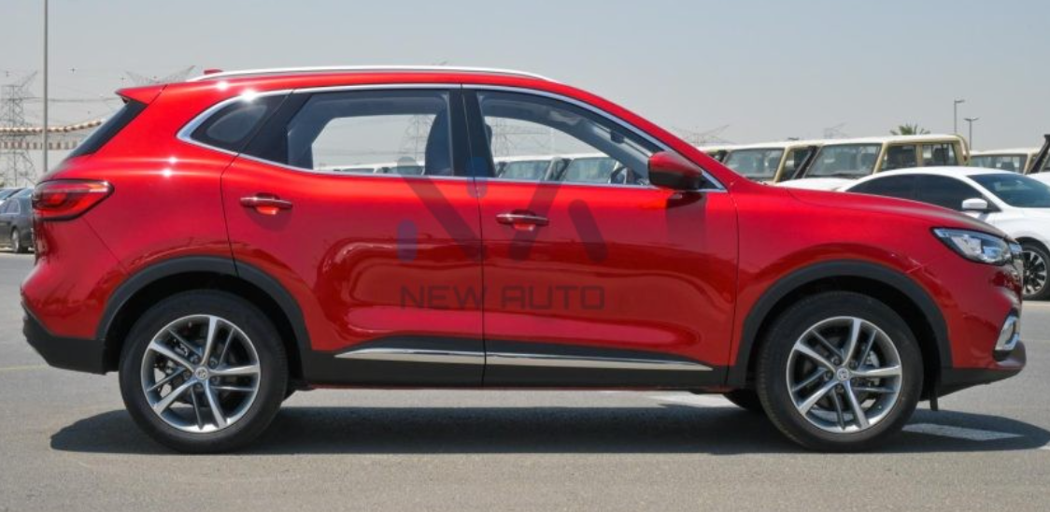

**Main Specifications** of the **2023 MG HS**

**📏 Dimensions & Weight**

* **Length × Width × Height**: 4,574 × 1,876 × 1,664 mm
* **Wheelbase**: 2,720 mm
* **Ground Clearance**: 175 mm
* **Kerb Weight**: ≈1,550 kg (varies 1,516–1,775 kg depending on trim)
* **Boot Space**: 463 L (seats up); 1,375 L with seats folded

**🚗 Powertrain Options**

1. **1.5 L Turbocharged Petrol (DCT)**
   * **Engine**: 1,490–1,500 cc Turbo I4
   * **Power**: ~162 hp @ 5,500–5,600 rpm
   * **Torque**: 250–294 Nm @ 1,500–4,400 rpm
   * **Transmission**: 7-speed Dual-Clutch (DCT) or 6-speed manual in some markets
   * **Drive**: FWD
   * **Top Speed**: ~190 km/h
   * **0–100 km/h**: ~9.6–9.9 s
2. **2.0 L Turbo Petrol**
   * **Power**: ~231 hp
   * **Torque**: 360 Nm
   * **Transmission**: 6-speed DCT
   * **Drive**: FWD (some AWD available)
   * **Top Speed**: ~210 km/h
3. **1.5 L Turbo Plug-In Hybrid (PHEV)**
   * **Combined Power**: ~258 hp
   * **Combined Torque**: 370 Nm
   * **Battery**: ~14.9–16.6 kWh
   * **EV Range**: ~32 km (WLTP)
   * **Transmission**: 10-speed EDU II auto
   * **0–100 km/h**: ~6.9 s

**⛽ Fuel & Efficiency**

* **1.5 L Petrol**: ~7.7 L/100 km combined (~30 US mpg)
* **2.0 L Petrol**: ~9.5 L/100 km
* **PHEV**: ~1.8 L/100 km WLTP; EV range ~32 km

**🛞 Chassis, Suspension & Brakes**

* **Front Suspension**: MacPherson strut
* **Rear Suspension**: Multi-link
* **Brakes**: Front ventilated discs; rear solid discs with ABS/EBD
* **Wheels/Tires**: 18″ alloy wheels with 235/50 R18 tires
* **Steering**: Electric rack & pinion; turning radius ~5.9 m

**🛋️ Interior & Tech**

* **Infotainment**: 10.1″ touchscreen with MG Pilot safety suite (AEB, Lane Keep, ACC, Blind‑Spot, 360‑camera
* **Climate**: Dual-zone automatic AC; ambient lighting
* **Comfort**: Leather seats on higher trims; panoramic sunroof
* **Safety**: Up to 6 airbags, ESC, traction control; 5-star Euro NCAP rating

**💸 Pakistan-Specific Info**

* **Prices**: ~PKR 8.7–8.9 million (2023; Essence trim)
* **Fuel Real-World**:
  + City: ~7–10 km/L;
  + Highway: ~12–15 km/L depending on traffic and usage
* **User Feedback** (Reddit PK): Generally praised for drive and features, but flagged for DCT heat, fuel usage, and dependency on high-octane petrol

**✅ Summary**

The 2023 MG HS offers strong value with:

* A choice of efficient 1.5 L turbo petrol, more powerful 2.0 L petrol, or a compelling PHEV hybrid
* Spacious cabin (463 L boot) and family-friendly features
* Smooth ride and modern safety with advanced driver assistance
* PHEV presents ~32 km EV range, excellent fuel efficiency (1.8 L/100 km WLTP)
* In Pakistan, it’s well-equipped but can have higher fuel use and DCT quirks; premium fuel is essential